NOTICE OF 2017 ANNUAL GENERAL MEETING

Members are invited to attend the Annual General Meeting of the Adolescent Success Association which will be held at the Brisbane Convention and Exhibition Centre, Merivale St Street, South Brisbane, Queensland on Saturday 26 August 2017 at 12:30pm.

The following business will be transacted at this meeting:
- receipt of the statement of income and expenditure, assets and liabilities and of mortgages, charges and securities affecting the property of the association for the last financial year
- receipt of the auditor's report on the financial affairs of the association for the last financial year
- presentation of the audited statement to the meeting for adoption
- election of members of the management committee. (All positions on the Management Committee shall become vacant at this meeting.)
- appointment of an auditor
- motions for change to the Adolescent Success constitution.

All financial members are entitled to one (1) vote and may appoint a proxy vote on the proposed motions. This includes institutional members (schools, universities, colleges etc) who shall have one (1) vote per institution. Members may also choose to post their vote or vote online.

Forms relating to both proxy and postal voting will be sent out after nominations close on 31 July.

Electronic voting for the Management Committee positions and on the proposed changes the Adolescent Success constitution will be available to current financial members through the Adolescent Success website.

Online voting will open on Friday 11 August 2017 and closes on Monday 21 August 2017 a reminder of this will b emailed to all members with a link to the voting form.

Proxy and postal votes must be received no later than Monday 21 August, 2017.

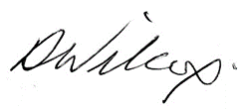
Regards

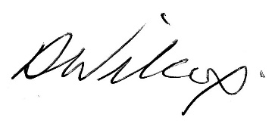
David Wilcox
Secretary

Postal address: Adolescent Success Inc. PO Box 2175 Toowong Q 4066
Email address: angela@adolescentsuccess.org.au

